Database access control is a method of allowing access to company’s sensitive data only to those people (database users) who are allowed to access such data and to restrict access to unauthorized persons. It includes two main components: authentication and authorization.

Authentication is a method of verifying the identity of a person who is accessing your database. Note that authentication isn’t enough to protect data. An additional layer of security is required, authorization, which determines whether a user should be allowed to access the data or make the transaction he’s attempting. Without authentication and authorization, there is no data security.

Any company whose employees connect to the Internet, thus, every company today, needs some level of access control implemented.

Types of Access Control
Obsolete access models include Discretionary Access Control (DAC) and Mandatory Access Control (MAC). Role Based Access Control (RBAC) is the most common method today, and the most recent model is Attribute Based Access Control (ABAC).

Discretionary Access Control (DAC)
With DAC models, the data owner allows access. DAC is a means of assigning access rights based on user-specified rules.

Mandatory Access Control (MAC)
MAC was developed using a nondiscretionary model, in which people are granted access based on an information clearance. MAC is a policy in which access rights are assigned based on central authority regulations.

Role Based Access Control (RBAC)
RBAC grants access based on a user’s role and implements key security principles such as “least privilege” and “separation of privilege.” Thus, someone attempting to access information can only access data necessary for their role.

Choosing the Right Model:
DAC: Suitable for smaller, more collaborative environments where flexibility is prioritized.
MAC: Ideal for highly sensitive environments where strict security is paramount.
RBAC: Best for larger organizations with well-defined roles and responsibilities.
mandatory access control:

What is mandatory access control? Mandatory access control (MAC) is a model of access control where the operating system provides users with access based on data confidentiality and user clearance levels. In this model, access is granted on a need to know basis: users have to prove a need for information before gaining access. MAC is also called a non-discretionary control model, which means that control isn’t gained at the discretion of the user or file owner. MAC implements zero-trust principles with its control mechanisms. MAC is considered the most secure of all access control models. Access rules in this model are manually defined by system administrators and strictly enforced by the operating system or security kernel. Regular users can’t alter security attributes even for data they’ve created.
What are the basic principles of MAC?
- The utmost privacy and confidentiality of the organization’s resources are paramount. No one has default privileges to access or edit someone’s data.
- Access provisioning is centrally administered.
- Each individual and resource in the system has security labels with their classification and category.

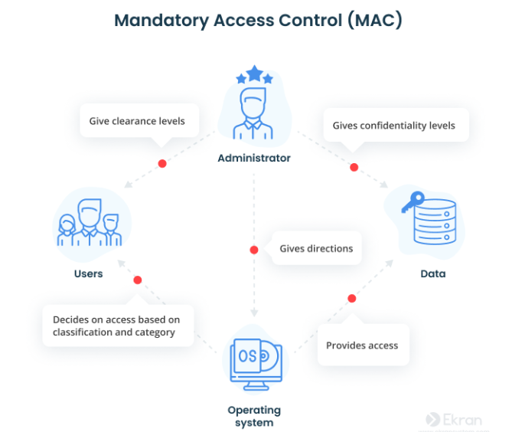

With MAC, the process of gaining access looks like this:
- The administrator configures access policies and defines security attributes: confidentiality levels, clearances for accessing different projects and types of resources.
- The administrator assigns each subject (user or resource that accesses data) and object (file, database, port, etc.) a set of attributes.
- When a subject attempts to access an object, the operating system examines the subject’s security attributes and decides whether access can be granted.
- To obtain access to the object, the user provides their credentials.
In addition to checking confidentiality and clearance levels (classification matches between subject and object), operating systems pay attention to category matches between subject and object. Having a “top secret” classification doesn’t automatically provide a user with full access to a file if they aren’t a member of the required category for the object.
Let’s take a look at the example of mandatory access control implementation. Assume that an organization possesses data that has the “top secret” confidentiality level and “engineering proje
ct” security label. It’s available to a set of users that have both “top secret” clearance (classification) and authorization to access engineering documents (category). Such users can also access information that requires a lower level of clearance. But employees with lower levels of clearance or no rights to access engineering documents can’t access such information.
Pros
High level of data protection — An administrator defines access to objects, and users can’t alter that access.
Granularity — An administrator sets user access rights and object access parameters manually.
Immunity to Trojan Horse attacks — Users can’t declassify data or share access to classified data.
Fewer errors — Strict and constantly controlled policies help reduce system errors that lead to over-privileged users.
Strict division — Admins divide users into subsets and limit resource exposure for these subsets using security attributes.
Cons
Maintainability — Manual configuration of security levels and clearances requires constant attention from administrators.
Scalability — MAC doesn’t scale automatically. New users and pieces of data demand constant updates in objects and account configurations.
Interference with users’ work — Users have to request access to each new piece of data; they can’t configure access parameters for their own data.
This access control model is mostly used by government organizations, militaries, and law enforcement institutions
Discretionary access control
What is discretionary access control? Discretionary access control is an identity-based access control model that provides users with a certain amount of control over their data. Data owners (document creators or any users authorized to control data) can define access permissions for specific users or groups of users. In other words, whom to give access to and what privileges to grant are decided at the resource owner’s discretion.
Access permissions for each piece of data are stored in an access control list (ACL). An administrator creates this list when a user grants access to somebody. The list can be generated automatically. An ACL includes users and groups that may access data and the levels of access they have. A system administrator can also enforce an ACL. In this case, the ACL acts as a security policy, and regular users can’t edit or overrule it.
What are the basic principles of DAC?
- Object characteristics (size, name, directory path) are invisible to users that aren’t authorized.
- Several failed access attempts enforce additional multi-factor authentication or deny access.
- Users can transfer their object ownership to other users. Also, the owner determines the access type of other users. Based on these access privileges, the operating system decides whether to grant access to a file.
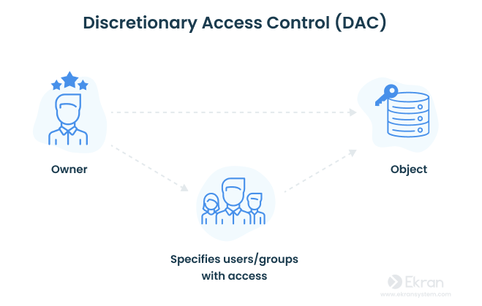

Gaining access to a file in the DAC model works like this:
- User 1 creates a file and becomes its owner, or obtains access rights to an existing file.
- User 2 requests access to this file. They provide their credentials: username, password, or something else.
- User 1 grants access at their discretion. However, user 1 can’t grant access rights that exceed their own. For example, if user 1 can only read a document, they can’t allow user 2 to edit it.
- If there’s no contradiction between the ACL created by an administrator and the decision made by user 1, access is granted.

Discretionary access control is quite a popular model because it allows a lot of freedom for users and doesn’t cause administrative overhead. However, it has several considerable limitations.
Pros
User-friendly — Users can manage their data and quickly access data of other users.
Flexible — Users can configure data access parameters without administrators.
Easy to maintain — Adding new objects and users doesn’t take much time for the administrator.
Granular — Users can configure access parameters for each piece of data.
Cons
Low level of data protection — DAC can’t ensure reliable security because users can share their data however they like.
Obscure access management — There’s no centralized access management, so in order to find out access parameters, you have to check each ACL.
Overlay of user privileges— A permissions conflict may happen with users of multiple nested workgroups.
When to use DAC
DAC shouldn’t be used by organizations that work with extremely sensitive data (medical, financial, military, etc.) for several reasons:
- If user 1 shares access rights with user 2, there’s no guarantee that user 2 needs this access to work, won’t steal or corrupt data, and won’t grant access to a malicious user.
- It’s impossible to control information flows inside the network.
- It’s impossible to enforce the principles of least privilege, need to know, and separation of duties.
Role-Based Access Control (RBAC):
- Permissions assigned to roles, not individuals: Users are assigned roles (e.g., manager, developer, accountant) with predefined permissions.
- Efficient and scalable: Easier to manage permissions for large numbers of users.
- Enforces least privilege: Users only have access to what they need for their job.
- Commonly used in commercial and enterprise systems.
Role Based Access Control is an approach used to restrict system access to authorised users only.
In essence it is how you delegate permissions from specific tasks to a specific group, to which relevant user accounts are then added. The below picture shows this in a visual manner.
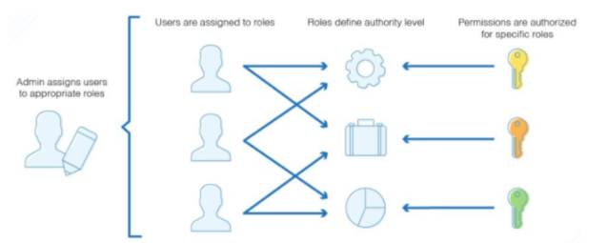
This approach stops excessive permissions being granted to accounts. The main benefits of this are that if an individual account is compromised you will not have exposed all (or a large number of) systems as the access of this individual account will be very specific and restricted.
RBAC lets employees have access rights only to the information they need to do their jobs and prevents them from accessing information that doesn’t pertain to them.
In the role-based access control data model, roles are based on several factors, including authorization, responsibility and job competency. As such, companies can designate whether a user is an end user, an administrator or a specialist user. In addition, access to computer resources can be limited to specific tasks, such as the ability to view, create or modify files. An employee’s role in an organization determines the permissions that individual is granted and ensures that employees can’t access sensitive information or perform high-level tasks that are not required for their own role.
Least Privilege in RBAC
It's a fundamental security principle that dictates granting users only the minimum permissions necessary to perform their job duties, reducing the potential for unauthorized access and damage.
How RBAC Enforces Least Privilege:
- Role-Based Permissions: Permissions are assigned to roles, not individuals. This ensures users only have access to resources that align with their defined job responsibilities.
- Separation of Duties: Different roles have distinct permissions, preventing a single user from having excessive control over sensitive data or operations.
- Minimal Permissions: Each role is granted only the essential permissions for its tasks, minimizing the attack surface if a user's credentials are compromised.
- Regular Reviews: Roles and permissions are periodically reviewed and adjusted as needed to maintain least privilege, ensuring alignment with evolving business needs and security requirements.
Benefits of Least Privilege in RBAC:
- Reduced Risk of Data Breaches: Minimizes the likelihood of unauthorized access, data theft, or malicious activity.
- Protection Against Insider Threats: Constraints on user access hinder employees from abusing their privileges for personal gain or malicious purposes.
- Compliance with Regulatory Standards: Many regulations mandate least privilege access controls, and RBAC helps organizations meet these requirements.
- Simplified Access Management: Managing permissions at the role level streamlines administration and reduces the potential for errors.
- Enhanced Auditability: Tracking user access based on roles enables more effective monitoring and auditing of database activity.
Example:
A user with the "Data Analyst" role might have read access to customer data but not the ability to modify or delete it, ensuring data integrity and preventing accidental or intentional data corruption.
RBAC, when implemented with a least privilege approach, significantly strengthens database security, minimizes risk, and fosters compliance with regulatory standards.

Intrusion detection systems (IDS)
Database security is crucial in today's digital world, where confidential information and sensitive data reside. Protecting against malicious actors who attempt unauthorized access, data manipulation, or disruption requires a layered approach. This includes intrusion detection mechanisms to identify and respond to suspicious activity within your database system.
A system called an intrusion detection system (IDS) observes network traffic for malicious transactions and sends immediate alerts when it is observed. It is software that checks a network or system for malicious activities or policy violations. Each illegal activity or violation is often recorded either centrally using a SIEM system or notified to an administration. IDS monitors a network or system for malicious activity and protects a computer network from unauthorized access from users, including perhaps insiders. The intrusion detector learning task is to build a predictive model (i.e. a classifier) capable of distinguishing between ‘bad connections’ (intrusion/attacks) and ‘good (normal) connections’.
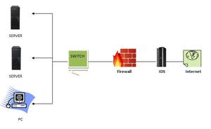

How does an IDS work?
- An IDS (Intrusion Detection System) monitors the traffic on a computer network to detect any suspicious activity.
- It analyzes the data flowing through the network to look for patterns and signs of abnormal behavior.
- The IDS compares the network activity to a set of predefined rules and patterns to identify any activity that might indicate an attack or intrusion.
- If the IDS detects something that matches one of these rules or patterns, it sends an alert to the system administrator.
- The system administrator can then investigate the alert and take action to prevent any damage or further intrusion.

Classification of Intrusion Detection System
IDS are classified into 5 types:
- Network Intrusion Detection System (NIDS): Network intrusion detection systems (NIDS) are set up at a planned point within the network to examine traffic from all devices on the network. It performs an observation of passing traffic on the entire subnet and matches the traffic that is passed on the subnets to the collection of known attacks. Once an attack is identified or abnormal behavior is observed, the alert can be sent to the administrator. An example of a NIDS is installing it on the subnet where firewalls are located in order to see if someone is trying to crack the firewall.
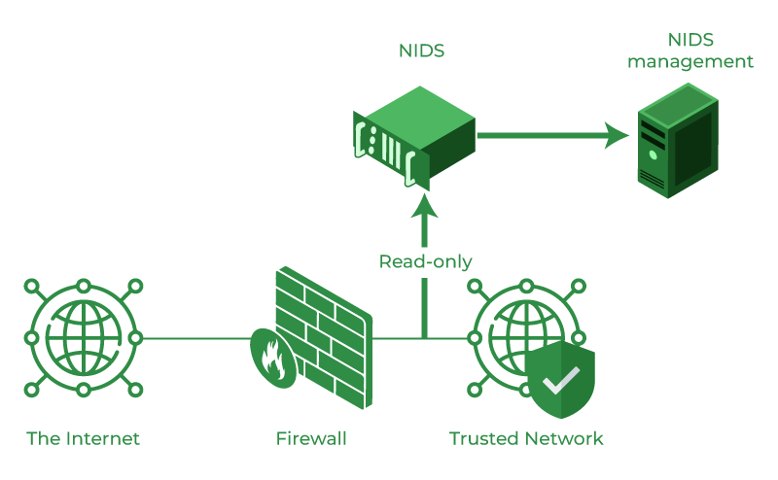

- Host Intrusion Detection System (HIDS): Host intrusion detection systems (HIDS) run on independent hosts or devices on the network. A HIDS monitors the incoming and outgoing packets from the device only and will alert the administrator if suspicious or malicious activity is detected. It takes a snapshot of existing system files and compares it with the previous snapshot. If the analytical system files were edited or deleted, an alert is sent to the administrator to investigate. An example of HIDS usage can be seen on mission-critical machines, which are not expected to change their layout.
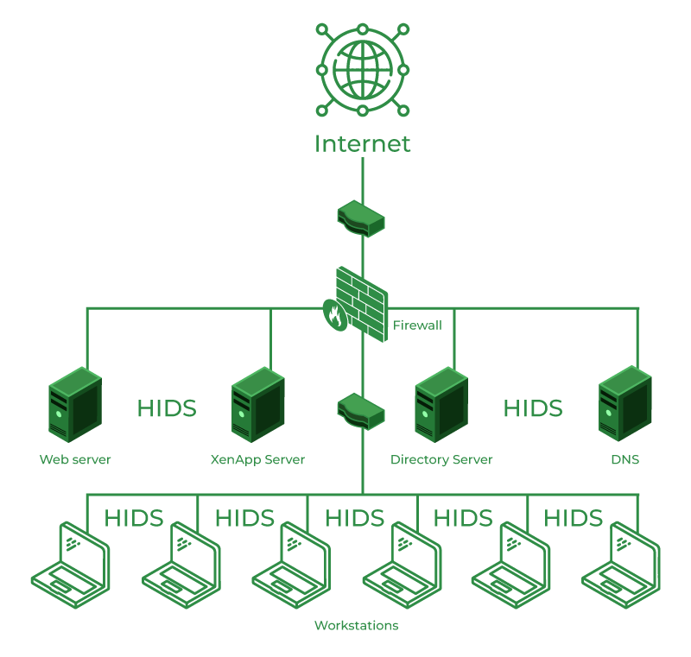
- Protocol-based Intrusion Detection System (PIDS): Protocol-based intrusion detection system (PIDS) comprises a system or agent that would consistently reside at the front end of a server, controlling and interpreting the protocol between a user/device and the server. It is trying to secure the web server by regularly monitoring the HTTPS protocol stream and accepting the related HTTP protocol. As HTTPS is unencrypted and before instantly entering its web presentation layer then this system would need to reside in this interface, between to use the HTTPS.
- Application Protocol-based Intrusion Detection System (APIDS): An application Protocol-based Intrusion Detection System (APIDS) is a system or agent that generally resides within a group of servers. It identifies the intrusions by monitoring and interpreting the communication on application-specific protocols. For example, this would monitor the SQL protocol explicitly to the middleware as it transacts with the database in the web server.
- Hybrid Intrusion Detection System: Hybrid intrusion detection system is made by the combination of two or more approaches to the intrusion detection system. In the hybrid intrusion detection system, the host agent or system data is combined with network information to develop a complete view of the network system. The hybrid intrusion detection system is more effective in comparison to the other intrusion detection system. Prelude is an example of Hybrid IDS.

Benefits of IDS
- Detects malicious activity: IDS can detect any suspicious activities and alert the system administrator before any significant damage is done.
- Improves network performance: IDS can identify any performance issues on the network, which can be addressed to improve network performance.
- Compliance requirements: IDS can help in meeting compliance requirements by monitoring network activity and generating reports.
- Provides insights: IDS generates valuable insights into network traffic, which can be used to identify any weaknesses and improve network security.

Detection Method of IDS
- Signature-based Method: Signature-based IDS detects the attacks on the basis of the specific patterns such as the number of bytes or a number of 1s or the number of 0s in the network traffic. It also detects on the basis of the already known malicious instruction sequence that is used by the malware. The detected patterns in the IDS are known as signatures. Signature-based IDS can easily detect the attacks whose pattern (signature) already exists in the system but it is quite difficult to detect new malware attacks as their pattern (signature) is not known.
- Anomaly-based Method: Anomaly-based IDS was introduced to detect unknown malware attacks as new malware is developed rapidly. In anomaly-based IDS there is the use of machine learning to create a trustful activity model and anything coming is compared with that model and it is declared suspicious if it is not found in the model. The machine learning-based method has a better-generalized property in comparison to signature-based IDS as these models can be trained according to the applications and hardware configurations.

SQL injection
SQL injection, also known as SQLI, is a common attack vector that uses malicious SQL code for backend database manipulation to access information that was not intended to be displayed. This information may include any number of items, including sensitive company data, user lists or private customer details.

The impact SQL injection can have on a business is far-reaching. A successful attack may result in the unauthorized viewing of user lists, the deletion of entire tables and, in certain cases, the attacker gaining administrative rights to a database, all of which are highly detrimental to a business.
A typical eStore’s SQL database query may look like the following:
SELECT ItemName, ItemDescription
FROM Item
WHERE ItemNumber = ItemNumber
From this, the web application builds a string query that is sent to the database as a single SQL statement:
sql_query= "
SELECT ItemName, ItemDescription
FROM Item
WHERE ItemNumber = " & Request.QueryString("ItemID")
A user-provided input http://www.estore.com/items/items.asp?itemid=999 can then generates the following SQL query:
SELECT ItemName, ItemDescription
FROM Item
WHERE ItemNumber = 999
As you can gather from the syntax, this query provides the name and description for item number 999.

Types of SQL Injections
SQL injections typically fall under three categories: In-band SQLi (Classic), Inferential SQLi (Blind) and Out-of-band SQLi. You can classify SQL injections types based on the methods they use to access backend data and their damage potential.

In-band SQLi
The attacker uses the same channel of communication to launch their attacks and to gather their results. In-band SQLi’s simplicity and efficiency make it one of the most common types of SQLi attack. There are two sub-variations of this method:
- Error-based SQLi—the attacker performs actions that cause the database to produce error messages. The attacker can potentially use the data provided by these error messages to gather information about the structure of the database.
- Union-based SQLi—this technique takes advantage of the UNION SQL operator, which fuses multiple select statements generated by the database to get a single HTTP response. This response may contain data that can be leveraged by the attacker.

Inferential (Blind) SQLi
The attacker sends data payloads to the server and observes the response and behavior of the server to learn more about its structure. This method is called blind SQLi because the data is not transferred from the website database to the attacker, thus the attacker cannot see information about the attack in-band.
Blind SQL injections rely on the response and behavioral patterns of the server so they are typically slower to execute but may be just as harmful. Blind SQL injections can be classified as follows:
- Boolean—that attacker sends a SQL query to the database prompting the application to return a result. The result will vary depending on whether the query is true or false. Based on the result, the information within the HTTP response will modify or stay unchanged. The attacker can then work out if the message generated a true or false result.
- Time-based—attacker sends a SQL query to the database, which makes the database wait (for a period in seconds) before it can react. The attacker can see from the time the database takes to respond, whether a query is true or false. Based on the result, an HTTP response will be generated instantly or after a waiting period. The attacker can thus work out if the message they used returned true or false, without relying on data from the database.

Out-of-band SQLi
The attacker can only carry out this form of attack when certain features are enabled on the database server used by the web application. This form of attack is primarily used as an alternative to the in-band and inferential SQLi techniques.
Out-of-band SQLi is performed when the attacker can’t use the same channel to launch the attack and gather information, or when a server is too slow or unstable for these actions to be performed. These techniques count on the capacity of the server to create DNS or HTTP requests to transfer data to an attacker.

SQL injection example
An attacker wishing to execute SQL injection manipulates a standard SQL query to exploit non-validated input vulnerabilities in a database. There are many ways that this attack vector can be executed, several of which will be shown here to provide you with a general idea about how SQLI works.
For example, the above-mentioned input, which pulls information for a specific product, can be altered to read http://www.estore.com/items/items.asp?itemid=999 or 1=1.
As a result, the corresponding SQL query looks like this:
SELECT ItemName, ItemDescription
FROM Items
WHERE ItemNumber = 999 OR 1=1
And since the statement 1 = 1 is always true, the query returns all of the product names and descriptions in the database, even those that you may not be eligible to access.
Attackers are also able to take advantage of incorrectly filtered characters to alter SQL commands, including using a semicolon to separate two fields.
For example, this input http://www.estore.com/items/iteams.asp?itemid=999; DROP TABLE Users would generate the following SQL query:
SELECT ItemName, ItemDescription
FROM Items
WHERE ItemNumber = 999; DROP TABLE USERS
As a result, the entire user database could be deleted.
Another way SQL queries can be manipulated is with a UNION SELECT statement. This combines two unrelated SELECT queries to retrieve data from different database tables.
For example, the input http://www.estore.com/items/items.asp?itemid=999 UNION SELECT user-name, password FROM USERS produces the following SQL query:
SELECT ItemName, ItemDescription
FROM Items
WHERE ItemID = '999' UNION SELECT Username, Password FROM Users;
Using the UNION SELECT statement, this query combines the request for item 999’s name and description with another that pulls names and passwords for every user in the database.
Prevention Methods:
- Input Validation and Sanitization:
  - Rigorously validate and sanitize all user input before using it in SQL queries.
  - Use prepared statements or parameterized queries, which separate code from data.
- Error Handling:
  - Avoid displaying detailed database error messages to users.
- Least Privilege:
  - Grant database accounts only the permissions they need.
- Regular Security Updates:
  - Patch database software and application frameworks promptly.
- Web Application Firewalls (WAFs):
  - Can detect and block some SQL injection attempts.
- Penetration Testing:
  - Regularly test applications for vulnerabilities.

